PAIN ASSESSMENT

Patient’s Name: _________________________________________________ Patient’s #: ____________

Please mark the figures below with the letters that best describes the sensation or pain you are feeling. Please mark arrears where pain radiates or spread with an arrow , , or to indicate the direction of radiating pain.
(Include all affected areas)

A = Ache B = Burning R = Radiating Pain D = Dull Pain
0  No Pain | 1 2  Minimal | 3 4  Tolerable, but hinders Activities | 5 6  High - 50% of Activities Impaired | 7 8  Extreme - most activities impaired | 9  Unbearable
N = Numbness S = Stabbing P = Pins and Needles O = Other

Next to each area, mark the intensity of pain:

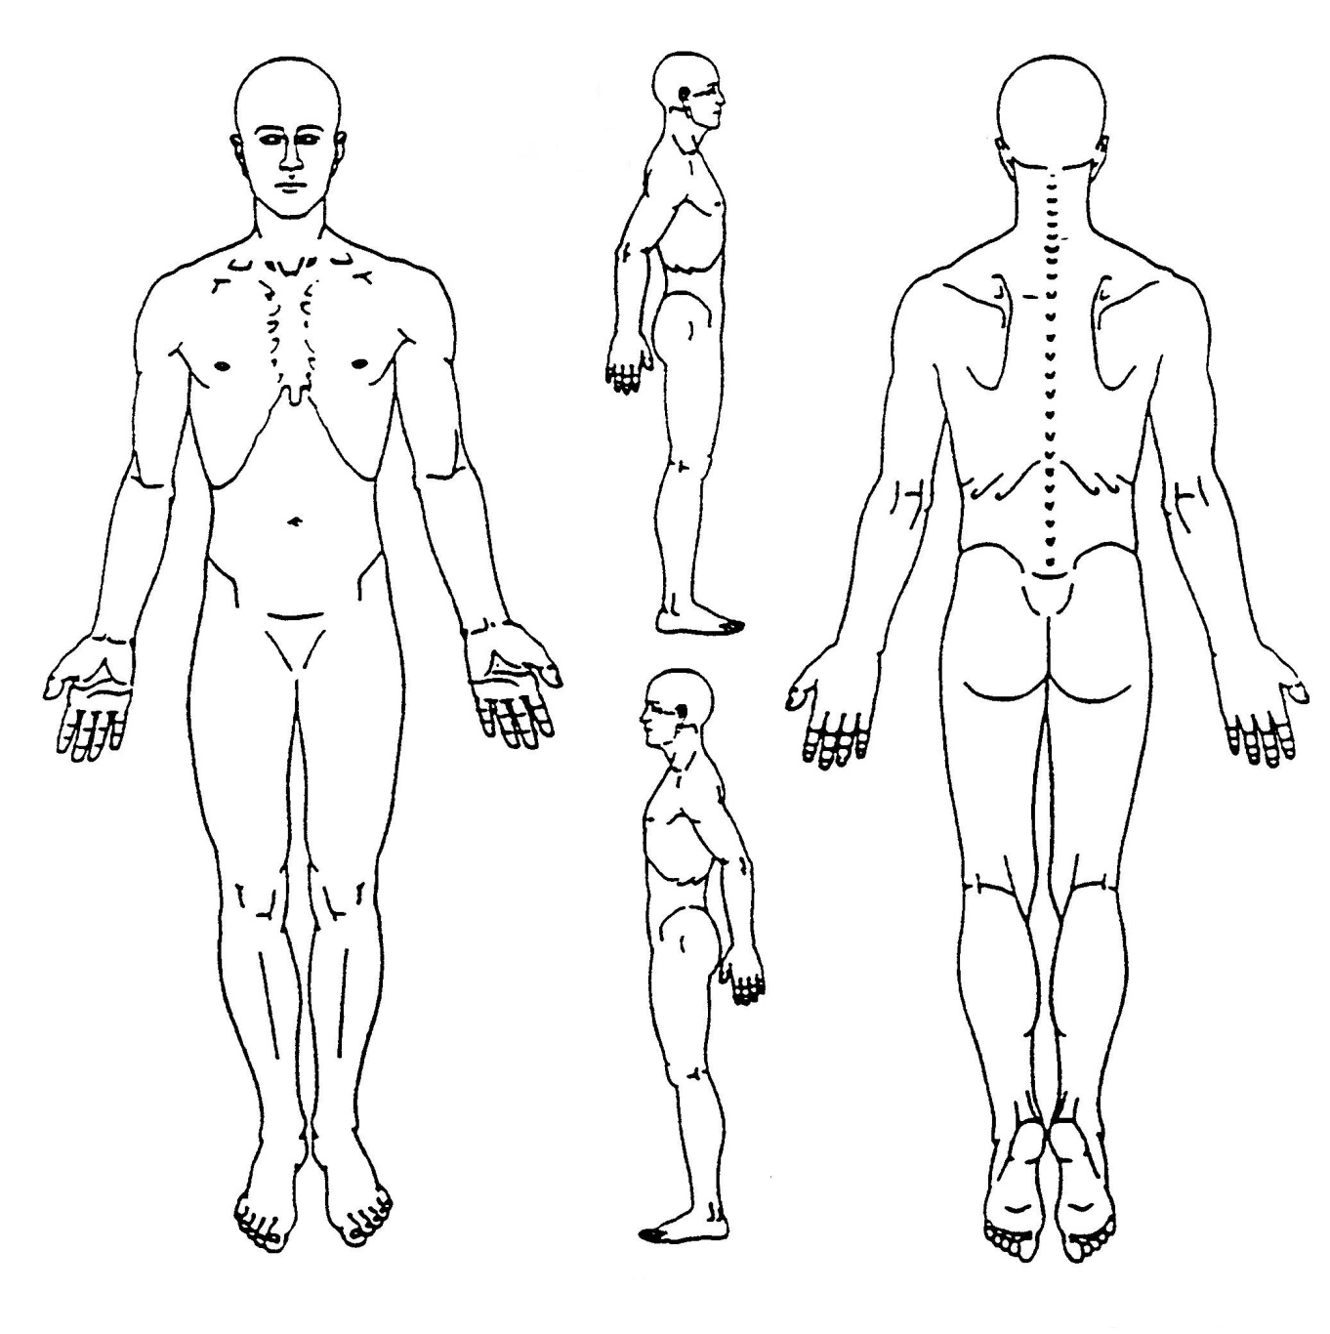

Patient’s Signature ___________________________________________ Date ____/____/____

